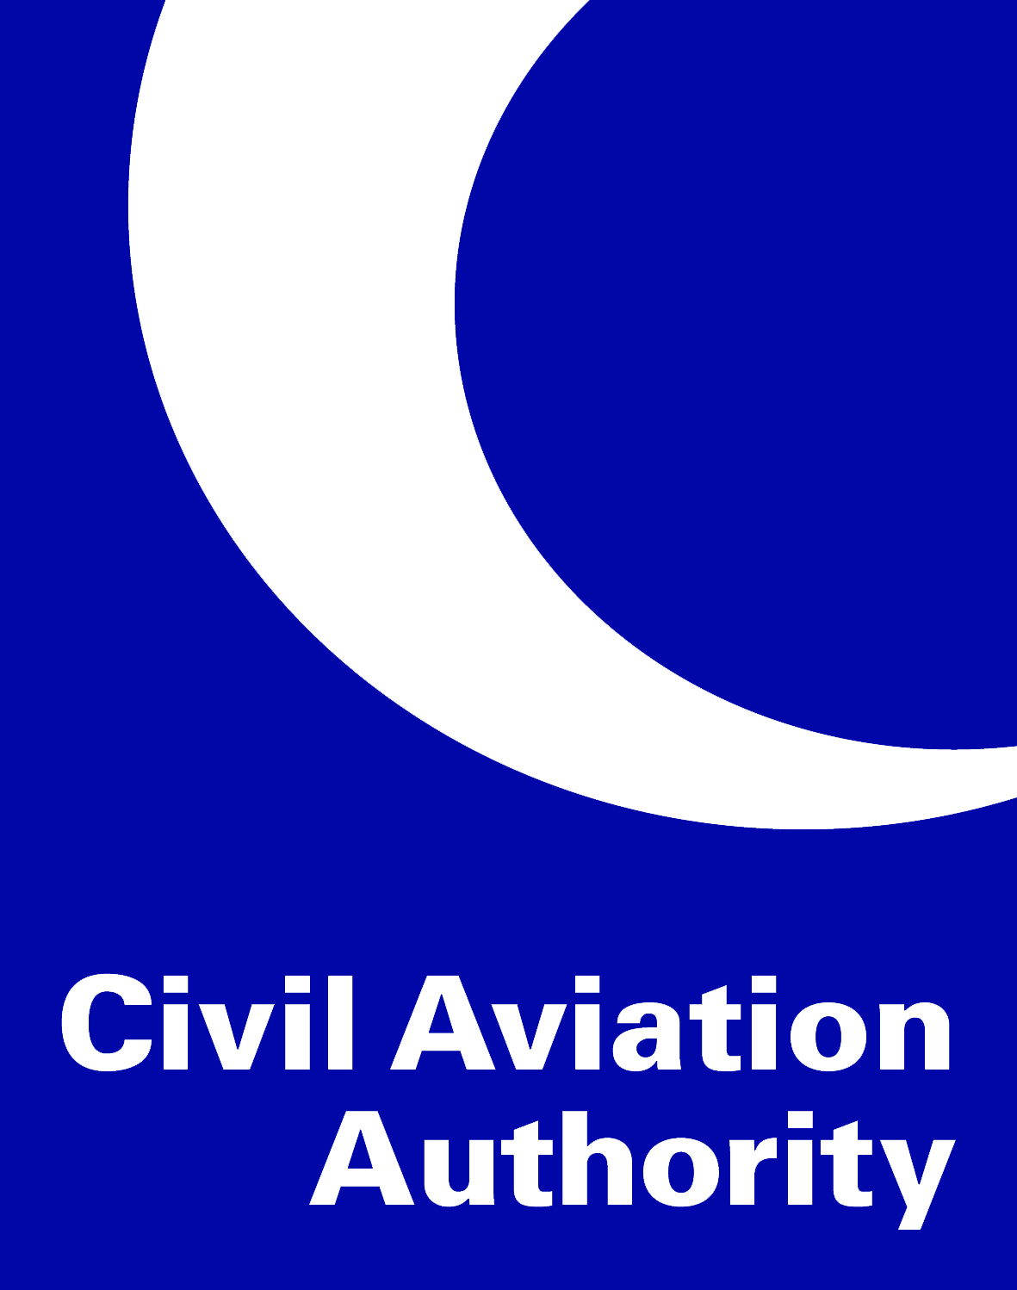

**EASA Aerodromes Transition**

**Operations Basis (OB)**

Name of Aerodrome:  
  
Date of issue:  
  
Version no:

**Annex III – Part organisation requirements – aerodrome operators**

**Annex III – Sub Part A – general requirements**

|  |  |  |
| --- | --- | --- |
| **ADR.OR.** | **Implementing Rule** | **Implementing Rule Read & Understood?** |
| A.005 | **Scope** | Choose an item. |
| A.010 | **Competent Authority** | Choose an item. |
| A.015 | **Means of Compliance** | Choose an item. |
| B.005 | **Certification obligations of aerodromes and aerodrome operators** | Choose an item. |

**Annex III – Sub Part B – certification**

|  |  |  |  |  |
| --- | --- | --- | --- | --- |
| **ADR.OR.** | **Implementing Rule** | **Implementing Rule Read & Understood?** | | |
| B.005 | **Certification obligations of aerodromes and aerodrome operators** | Choose an item. | | |
|  | | | | |
| **ADR.OR.** | **Implementing Rule** | **Rule met?** | **ALL EASA Acceptable Means of Compliance Used?** | **Aerodrome**  **Manual**  **Reference** |
| B.015 | **Application for a Certificate** | N/A | N/A |  |
|  | | | | |
| B.025 | **Demonstration of Compliance** | Choose an item. | Choose an item. |  |
|  | | | | |
|  | | | | |
| **ADR.OR.** | **Implementing Rule** | **Implementing Rule Read & Understood?** | | |
| B.030 | **Terms of the Certificate and privileges of the certificate holder** | Choose an item. | | |

|  |  |  |  |  |
| --- | --- | --- | --- | --- |
| **ADR.OR.** | **Implementing Rule** | **Rule met?** | **ALL EASA Acceptable Means of Compliance Used?** | **Aerodrome**  **Manual**  **Reference** |
| B.035 | **Continued validity of a Certificate** | Choose an item. | N/A |  |
|  | | | | |
| B.037 | **Continued validity of a declaration of a provider of apron management services** | N/A | N/A |  |
|  | | | | |
| B.040 | **Changes** | Choose an item. | Choose an item. |  |
| If ‘no’ please specify which part of the AMC has not been used and why, together with details of proposed Alternative Means of Compliance | | | | |
| B.050 | **Continuing compliance with the Agency’s certification specifications** | Choose an item. | N/A |  |
|  | | | | |
| B.060 | **Declaration of providers of apron management services** | N/A | N/A |  |
|  | | | | |
| B.065 | **Termination of operation** | Choose an item. | Choose an item. |  |
| If ‘no’ please specify which part of the AMC has not been used and why, together with details of proposed Alternative Means of Compliance | | | | |

**Annex III – Sub Part C – additional aerodrome operator responsibilities**

|  |  |  |  |  |
| --- | --- | --- | --- | --- |
| **ADR.OR.** | **Implementing Rule** | **Rule met?** | **ALL EASA Acceptable Means of Compliance Used?** | **Aerodrome**  **Manual**  **Reference** |
| C.005 | **Aerodrome Operator Responsibilities** | Choose an item. | Choose an item. |  |
| If ‘no’ please specify which part of the AMC has not been used and why, together with details of proposed Alternative Means of Compliance | | | | |
| C.015 | **Access** | Choose an item. | N/A |  |
|  | | | | |
| C.020 | **Finding and Corrective Actions** | Choose an item. | Choose an item. |  |
| If ‘no’ please specify which part of the AMC has not been used and why, together with details of proposed Alternative Means of Compliance | | | | |
| C.025 | **Immediate Reaction to a Safety Problem** | Choose an item. | N/A |  |
|  | | | | |
| C.030 | **Occurrence Reporting** | Choose an item. | Choose an item. |  |
| If ‘no’ please specify which part of the AMC has not been used and why, together with details of proposed Alternative Means of Compliance | | | | |
| C.040 | **Prevention of Fire** | Choose an item. | Choose an item. |  |
| If ‘no’ please specify which part of the AMC has not been used and why, together with details of proposed Alternative Means of Compliance | | | | |
| C.045 | **Use of alcohol, psychoactive substances and medicines** | Choose an item. | N/A |  |
|  | | | | |

**Annex III – Sub Part D – management**

|  |  |  |  |  |
| --- | --- | --- | --- | --- |
| **ADR.OR.** | **Implementing Rule** | **Rule met?** | **ALL EASA Acceptable Means of Compliance Used?** | **Aerodrome**  **Manual**  **Reference** |
| D.005 | **Management system** | Choose an item. | Choose an item. |  |
| If ‘no’ please specify which part of the AMC has not been used and why, together with details of proposed Alternative Means of Compliance | | | | |
| D.007 | **Management of aeronautical data and aeronautical information** | Choose an item. | Choose an item. |  |
| If ‘no’ please specify which part of the AMC has not been used and why, together with details of proposed Alternative Means of Compliance | | | | |
| D.010 | **Contracted activities** | Choose an item. | Choose an item. |  |
| If ‘no’ please specify which part of the AMC has not been used and why, together with details of proposed Alternative Means of Compliance | | | | |
| D.015 | **Personnel requirements** | Choose an item. | Choose an item. |  |
| If ‘no’ please specify which part of the AMC has not been used and why, together with details of proposed Alternative Means of Compliance | | | | |
| D.017 | **Training and proficiency check programmes** | Choose an item. | Choose an item. |  |
| If ‘no’ please specify which part of the AMC has not been used and why, together with details of proposed Alternative Means of Compliance | | | | |
| D.020 | **Facilities requirements** | Choose an item. | Choose an item. |  |
| If ‘no’ please specify which part of the AMC has not been used and why, together with details of proposed Alternative Means of Compliance | | | | |

|  |  |  |  |  |
| --- | --- | --- | --- | --- |
| **ADR.OR.** | **Implementing Rule** | **Rule met?** | **ALL EASA Acceptable Means of Compliance Used?** | **Aerodrome**  **Manual**  **Reference** |
| D.025 | **Coordination with other organisations** | Choose an item. | N/A |  |
|  | | | | |
| D.027 | **Safety programmes** | Choose an item. | Choose an item. |  |
| If ‘no’ please specify which part of the AMC has not been used and why, together with details of proposed Alternative Means of Compliance | | | | |
| D.030 | **Safety reporting system** | Choose an item. | Choose an item. |  |
| If ‘no’ please specify which part of the AMC has not been used and why, together with details of proposed Alternative Means of Compliance | | | | |
| D.035 | **Record keeping** | Choose an item. | Choose an item. |  |
| If ‘no’ please specify which part of the AMC has not been used and why, together with details of proposed Alternative Means of Compliance | | | | |

**Annex III – Sub Part E – aerodrome manual and documentation**

|  |  |  |  |  |
| --- | --- | --- | --- | --- |
| **ADR.OR.** | **Implementing Rule** | **Rule met?** | **ALL EASA Acceptable Means of Compliance Used?** | **Aerodrome**  **Manual**  **Reference** |
| E.005 | **Aerodrome manual** | Choose an item. | Choose an item. |  |
| If ‘no’ please specify which part of the AMC has not been used and why, together with details of proposed Alternative Means of Compliance | | | | |
| E.010 | **Documentation requirements** | Choose an item. | N/A |  |
|  | | | | |

**Annex IV – Part operations requirements – aerodromes**

**Annex IV – Sub Part A – aerodrome data**

|  |  |  |  |  |
| --- | --- | --- | --- | --- |
| **ADR.OPS.** | **Implementing Rule** | **Rule met?** | **ALL EASA Acceptable Means of Compliance Used?** | **Aerodrome**  **Manual**  **Reference** |
| A.005 | **Aerodrome Data** | Choose an item. | Choose an item. |  |
| If ‘no’ please specify which part of the AMC has not been used and why, together with details of proposed Alternative Means of Compliance | | | | |
| A.010 | **Data quality requirements** | Choose an item. | Choose an item. |  |
| If ‘no’ please specify which part of the AMC has not been used and why, together with details of proposed Alternative Means of Compliance | | | | |
| A.015 | **Coordination between aerodrome operators and providers of aeronautical information services** | Choose an item. | Choose an item. |  |
| If ‘no’ please specify which part of the AMC has not been used and why, together with details of proposed Alternative Means of Compliance | | | | |

**Annex IV – Sub Part B – aerodrome operational services, equipment and installations**

|  |  |  |  |  |
| --- | --- | --- | --- | --- |
| **ADR.OPS.** | **Implementing Rule** | **Rule met?** | **ALL EASA Acceptable Means of Compliance Used?** | **Aerodrome**  **Manual**  **Reference** |
| B.001 | **Provision of services** | Choose an item. | N/A |  |
|  | | | | |
| B.005 | **Aerodrome emergency planning** | Choose an item. | Choose an item. |  |
| If ‘no’ please specify which part of the AMC has not been used and why, together with details of proposed Alternative Means of Compliance | | | | |
| B.010 | **Rescue and firefighting services** | Choose an item. | Choose an item. |  |
| If ‘no’ please specify which part of the AMC has not been used and why, together with details of proposed Alternative Means of Compliance | | | | |
| B.015 | **Monitoring and inspection of movement area and related facilities** | Choose an item. | Choose an item. |  |
| If ‘no’ please specify which part of the AMC has not been used and why, together with details of proposed Alternative Means of Compliance | | | | |
| B.020 | **Wildlife strike hazard reduction** | Choose an item. | Choose an item. |  |
| If ‘no’ please specify which part of the AMC has not been used and why, together with details of proposed Alternative Means of Compliance | | | | |
| B.025 | **Operation vehicles** | Choose an item. | Choose an item. |  |
| If ‘no’ please specify which part of the AMC has not been used and why, together with details of proposed Alternative Means of Compliance | | | | |

|  |  |  |  |  |
| --- | --- | --- | --- | --- |
| **ADR.OPS.** | **Implementing Rule** | **Rule met?** | **ALL EASA Acceptable Means of Compliance Used?** | **Aerodrome**  **Manual**  **Reference** |
| B.030 | **Surface movement guidance and control system** | Choose an item. | Choose an item. |  |
| If ‘no’ please specify which part of the AMC has not been used and why, together with details of proposed Alternative Means of Compliance | | | | |
| B.035 | **Operations in winter conditions** | Choose an item. | Choose an item. |  |
| If ‘no’ please specify which part of the AMC has not been used and why, together with details of proposed Alternative Means of Compliance | | | | |
| B.040 | **Night operations** | Choose an item. | Choose an item. |  |
| If ‘no’ please specify which part of the AMC has not been used and why, together with details of proposed Alternative Means of Compliance | | | | |
| B.045 | **Low visibility operations** | Choose an item. | Choose an item. |  |
| If ‘no’ please specify which part of the AMC has not been used and why, together with details of proposed Alternative Means of Compliance | | | | |
| B.050 | **Operations in adverse weather conditions** | Choose an item. | Choose an item. |  |
| If ‘no’ please specify which part of the AMC has not been used and why, together with details of proposed Alternative Means of Compliance | | | | |
| B.055 | **Fuel quality** | Choose an item. | Choose an item. |  |
| If ‘no’ please specify which part of the AMC has not been used and why, together with details of proposed Alternative Means of Compliance | | | | |
| B.065 | **Visual aids and aerodrome electrical systems** | Choose an item. | Choose an item. |  |
| If ‘no’ please specify which part of the AMC has not been used and why, together with details of proposed Alternative Means of Compliance | | | | |
| **ADR.OPS.** | **Implementing Rule** | **Rule met?** | **ALL EASA Acceptable Means of Compliance Used?** | **Aerodrome**  **Manual**  **Reference** |
| B.070 | **Aerodrome works safety** | Choose an item. | Choose an item. |  |
| If ‘no’ please specify which part of the AMC has not been used and why, together with details of proposed Alternative Means of Compliance | | | | |
| B.075 | **Safeguarding of aerodromes** | Choose an item. | Choose an item. |  |
| If ‘no’ please specify which part of the AMC has not been used and why, together with details of proposed Alternative Means of Compliance | | | | |
| B.080 | **Marking and lighting of vehicles and other mobile objects** | Choose an item. | Choose an item. |  |
| If ‘no’ please specify which part of the AMC has not been used and why, together with details of proposed Alternative Means of Compliance | | | | |
| B.090 | **Use of aerodrome by higher code letter aircraft** | Choose an item. | Choose an item. |  |
| If ‘no’ please specify which part of the AMC has not been used and why, together with details of proposed Alternative Means of Compliance | | | | |

**Annex IV – Sub Part C – aerodrome maintenance**

|  |  |  |  |  |
| --- | --- | --- | --- | --- |
| **ADR.OPS.** | **Implementing Rule** | **Rule met?** | **ALL EASA Acceptable Means of Compliance Used?** | **Aerodrome**  **Manual**  **Reference** |
| C.005 | **General** | Choose an item. | Choose an item. |  |
| If ‘no’ please specify which part of the AMC has not been used and why, together with details of proposed Alternative Means of Compliance | | | | |
| C.010 | **Pavements, other ground surfaces and drainage** | Choose an item. | Choose an item. |  |
| If ‘no’ please specify which part of the AMC has not been used and why, together with details of proposed Alternative Means of Compliance | | | | |
| C.015 | **Visual aids and electrical systems** | Choose an item. | Choose an item. |  |
| If ‘no’ please specify which part of the AMC has not been used and why, together with details of proposed Alternative Means of Compliance | | | | |

**Aerodrome Operator Declaration**

I hereby confirm that the details provided within this Operations Basis are correct:

Signed: Print:

For and on behalf of:  
(Name of Aerodrome and Operator)

**FALSE REPRESENTATION STATEMENT**

**It is an offence under Article 256 of the Air Navigation Order 2016, as amended to make, with intent to deceive, any false representation for the purpose of procuring the grant, issue, renewal or variation of any certificate, licence, approval, permission or other document. This offence is punishable on summary conviction by a fine up to £5000, and on conviction on indictment with an unlimited fine or up to two years imprisonment or both.**

**CAA use only**

Documentation received:

Reviewed by: Print:

Approved by: Print:

Date: