EVENT RECORD TABLE
Event
(What Happened)
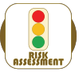
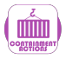
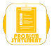
Phase | 1) Initial event information |  |  |  | 2) Subsequent investigation

When
Where
Who
How
Problem Statement
(Potential effects/risks)
Risk Assessment
Operation | Production | Review | Continue | STOP
 | Sales | Review | Continue | STOP
 | Operations | Review | Continue | STOP

Containment
Evidence
Human Factors | Evidence: |  |  |  | Conclusion:
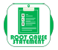
Root Cause Statement

Validation / timescale

